Post Incident Analysis Report
Incident Review and Continuous Improvement Assessment
General Information
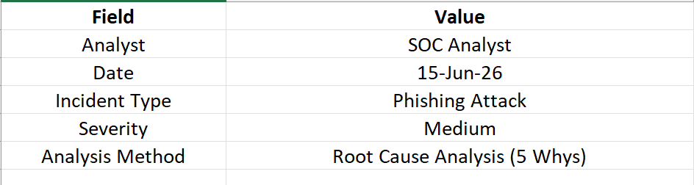
Executive Summary
A phishing attack was identified within the organization's network environment after a user received and interacted with a malicious email containing a fraudulent hyperlink. Security monitoring tools detected suspicious outbound communication shortly after the email was opened.
The incident was successfully contained through automated response procedures, and no critical systems were compromised. A post-incident review was conducted to identify contributing factors, evaluate response effectiveness, and recommend improvements to reduce the likelihood of future incidents.

Incident Description
On 15 June 2026, a user received an email disguised as an urgent account verification request. The email contained a malicious hyperlink designed to collect user credentials.
The recipient clicked the link, resulting in an attempted connection to a suspicious external domain. Security monitoring systems generated alerts, and the SOC team initiated investigation and containment procedures.

Incident Timeline
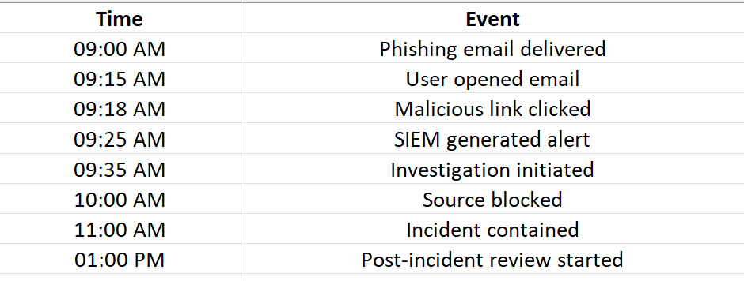
Root Cause Analysis (5 Whys)
Problem Statement
User interacted with a phishing email that bypassed security controls.
Why | Answer
Why was the phishing email opened? | User believed the email was legitimate.
Why did the user trust the email? | Email closely resembled an official communication.
Why was the email delivered to the inbox? | Existing email filtering rules failed to detect it.
Why did the filter fail? | Detection signatures were outdated.
Why were signatures outdated? | Regular review and update procedures were not being followed.

Root Cause
The primary root cause was insufficient maintenance of email security controls, combined with limited user awareness regarding phishing attacks.

Fishbone Analysis
People
- Lack of phishing awareness training
- User failed to verify sender legitimacy
Process
- Missing periodic email filter review
- No phishing simulation exercises
Technology
- Outdated email filtering rules
- Limited URL reputation validation
Policy
- Security awareness training not conducted regularly
- Incomplete phishing response procedures

Incident Response Evaluation
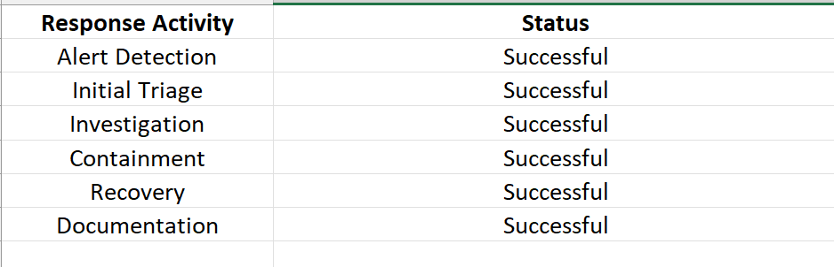
Security Metrics
Mean Time to Detect (MTTD)
Time between attack occurrence and detection.
Attack Time:
09:18 AM
Detection Time:
09:25 AM
MTTD:
7 Minutes

Mean Time to Respond (MTTR)
Time between detection and containment.
Detection Time:
09:25 AM
Containment Time:
11:00 AM
MTTR:
1 Hour 35 Minutes

Incident Resolution Time
Total duration from attack occurrence to full containment.
Resolution Time:
1 Hour 42 Minutes

Lessons Learned
- Email security filters require periodic updates.
- Security awareness training should be conducted quarterly.
- Automated URL reputation checking should be implemented.
- Playbooks should be reviewed regularly.
- Early detection significantly reduced incident impact.

Recommendations
Immediate Actions
- Update email filtering rules.
- Block identified malicious domains.
- Reset potentially exposed credentials.
Short-Term Improvements
- Conduct phishing awareness campaigns.
- Implement phishing simulation exercises.
- Improve SOC monitoring coverage.
Long-Term Improvements
- Deploy advanced email security solutions.
- Enhance SOAR automation.
- Review security policies annually.

Continuous Improvement Plan
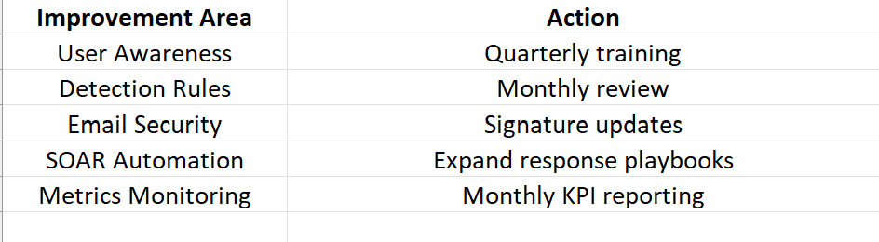
Conclusion
The phishing incident was detected and contained successfully with minimal organizational impact. Root Cause Analysis identified outdated email filtering mechanisms and insufficient user awareness as primary contributing factors. Through implementation of the recommended improvements, the organization can strengthen its defensive posture, improve detection capabilities, and reduce future phishing-related risks. Continuous monitoring, training, and process optimization remain essential components of an effective Security Operations Center.

